PEARLS AQI PREDICTOR
A 3-Day Air Quality Forecasting System for Sukkur, Pakistan
Project Report
Submitted By: Mudasir Ali Sandano
University: Institute of Business Administration
Submission Date: 06/09/2026

Table of Contents
1. Introduction 3
2. System Architecture 3
3. Data Sources and Feature Engineering 3
4. Exploratory Data Analysis 4
5. Model Development and Results 4
6. Forecasting Results 6
7. Automation and Web Dashboard 6
8. Technology Stack 7
9. Conclusion 7
Appendix A: Original Project Brief 8

1. Introduction
Air pollution is a growing concern in many South Asian cities, including Sukkur, Pakistan. For this project, I built an end-to-end machine learning system that predicts the Air Quality Index (AQI) for Sukkur up to three days in advance, using only free and publicly available data sources, so that the system remains 100% serverless and reproducible at no cost.
The project brief (Appendix A) asked for a complete pipeline covering automated data collection, feature engineering, model training and comparison, a model registry, scheduled automation, and an interactive dashboard with explainability and hazard alerting. My objectives were to:
- Collect historical and live weather and pollutant data for Sukkur.
- Engineer a clean, leakage-free set of predictive features.
- Train and compare multiple models (Ridge Regression, Random Forest, and a Neural Network).
- Explain predictions using SHAP feature-importance analysis.
- Automate the pipeline with GitHub Actions and serve forecasts through a live Streamlit dashboard.

2. System Architecture
I designed the system around the Feature / Training / Inference (FTI) pipeline pattern used in most production ML systems. Raw weather and pollutant data flows into a feature pipeline, which writes engineered features to a feature store; a training pipeline reads from the feature store, compares candidate models, and saves the best one to a model registry; and a Streamlit dashboard loads the latest model to serve live forecasts.
Weather & Pollution APIs → Feature Pipeline → Feature Store → Training Pipeline → Model Registry → Dashboard
A local CSV/pickle fallback stands in for the Feature Store and Model Registry whenever a Hopsworks API key is not configured, which let me build and test the whole pipeline immediately; the same code switches to the managed Hopsworks services once credentials are supplied. In production, two GitHub Actions workflows keep the system running automatically: one re-runs the feature pipeline every hour, and another re-trains the model once a day.

3. Data Sources and Feature Engineering

3.1 Data Sources
I used two free data providers, chosen to avoid signup friction: Open-Meteo, which supplies hourly historical and forecast weather (temperature, humidity, wind speed, pressure) and a ready-made US AQI value with no API key required, and the OpenWeather Air Pollution API, which supplies historical and forecast pollutant concentrations (PM2.5, PM10, CO, NO2, SO2). Location: Sukkur, Pakistan (27.7052°N, 68.8574°E), with a backfill window of roughly 35–92 days of hourly data.

3.2 Feature Engineering
Alongside standard calendar features (hour, day, month, day of week), I engineered lag-based features to capture short-term AQI momentum. My first attempt computed an “AQI change rate” as the current hour's AQI minus the previous hour's AQI — which I later identified as a data-leakage bug, since it uses the very value the model is meant to predict. I corrected this so the feature only uses already-known past values:
aqi_change_rate = aqi_lag_1 − aqi_lag_2

4. Exploratory Data Analysis
Figure 1 summarizes the historical dataset for Sukkur: AQI trend over time, its overall distribution, the average AQI by hour of day, and correlations between weather variables and AQI.
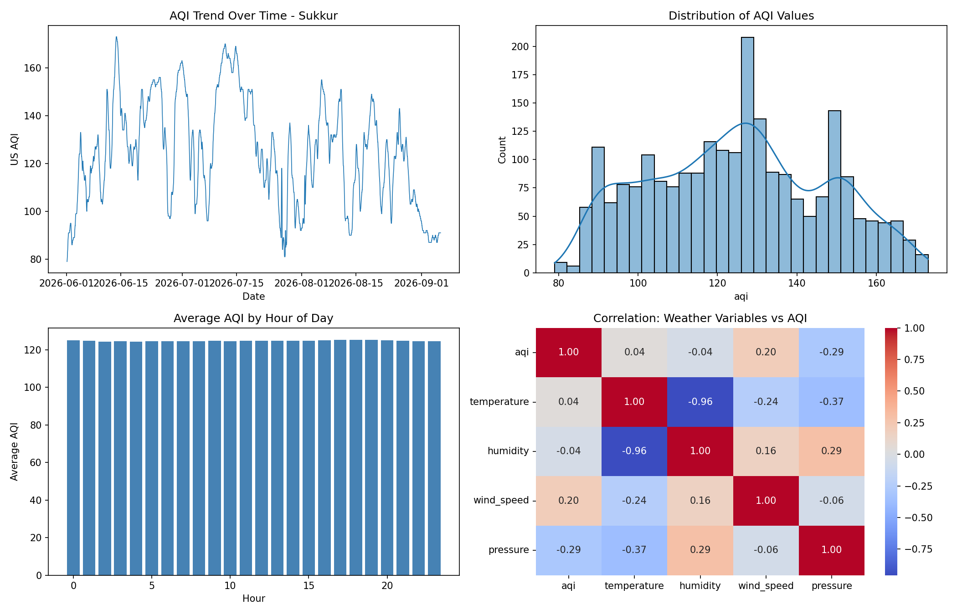
Figure 1. AQI trend, distribution, hourly pattern, and weather correlation for Sukkur.
AQI fluctuates between roughly 80 and 172 over the observed period, concentrated in the Moderate to Unhealthy-for-Sensitive-Groups range. Temperature and humidity are strongly inversely correlated (−0.96), as expected physically, while AQI itself correlates mildly with wind speed (+0.20) and pressure (−0.29).

5. Model Development and Results
Following the project brief, I trained and compared models spanning classical statistics to deep learning — Ridge Regression, Random Forest, and a small Neural Network (TensorFlow/Keras) — always splitting the data chronologically (oldest 80% for training, newest 20% for testing) rather than shuffling randomly, since forecasting problems must be evaluated on genuinely unseen future data.

5.1 Two Feature Sets Explored
I explored two feature engineering strategies. In an exploratory notebook, I predicted AQI from independently-forecastable weather variables plus AQI lag features. In the deployed production pipeline, I predicted AQI directly from forecasted pollutant concentrations. Evaluated on 840 real hourly observations for Sukkur (2 Aug – 5 Sep 2026; 672 train / 168 chronologically-held-out test rows), the production models scored:
Model | RMSE | MAE | R²
Ridge Regression | 0.08 | 0.06 | 1.000
Random Forest | 2.05 | 0.79 | 0.969

I selected Random Forest for deployment for its robustness, despite Ridge's marginally lower RMSE. I did not take these very low error values at face value — investigating further turned out to be one of the most valuable parts of this project (Section 5.2).

5.2 Key Finding: Why the Error Looked “Too Good”
Correlating the raw pollutant features against AQI revealed the answer: PM2.5 correlates with AQI at 1.000, PM10 at 0.889, NO2 at 0.224, SO2 at 0.086, and CO at −0.020. A correlation of exactly 1.000 means AQI is computed directly from PM2.5 by a fixed formula in this data source — so using PM2.5 as a model input is close to circular, and the near-perfect score reflects that formula, not genuine forecasting skill. SHAP confirms this: PM2.5 alone accounts for almost the entire prediction (Figure 2).
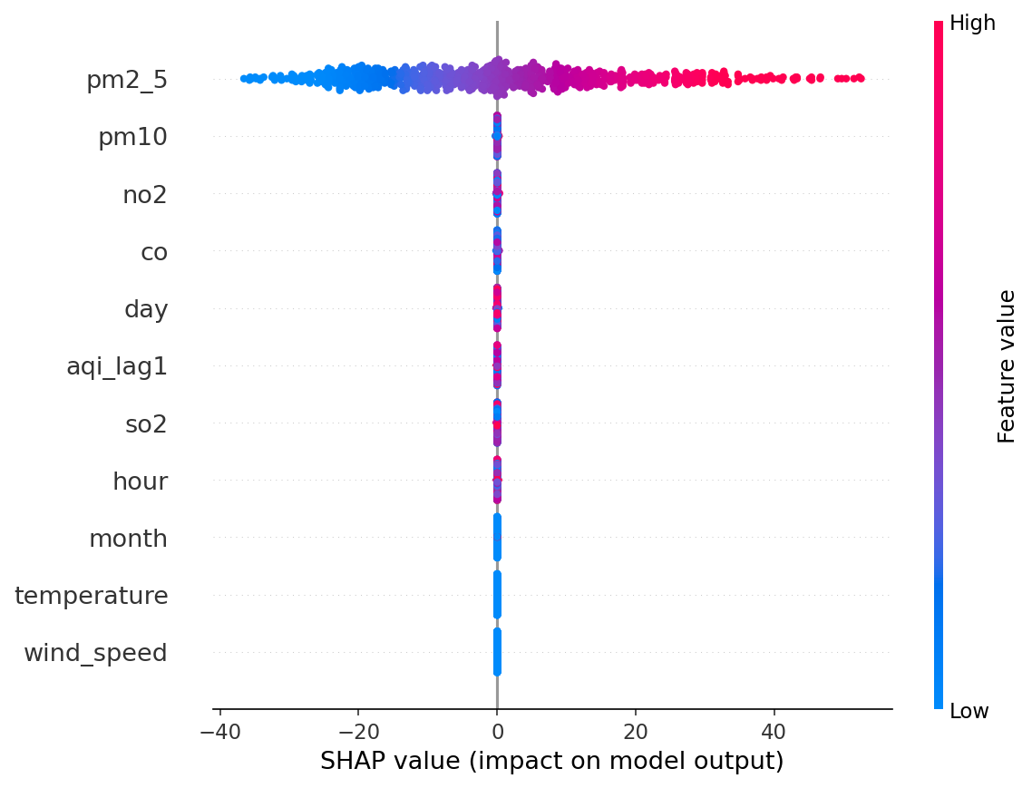
Figure 2. SHAP summary for the pollutant-based model — PM2.5 dominates almost completely.
By contrast, the weather-based exploratory model (Figure 3) shows a healthier profile: the two AQI lag features matter most, reflecting real short-term persistence, while weather variables add smaller but meaningful contributions — no single feature is fully deterministic. I also caught and fixed a second leakage issue along the way: an earlier version of the production script used a random (shuffled) train/test split, which let the model see temporally adjacent — and therefore very similar — hours on both sides of the split. Switching to a chronological split, together with the two findings above, gave me evaluation numbers I can actually trust.
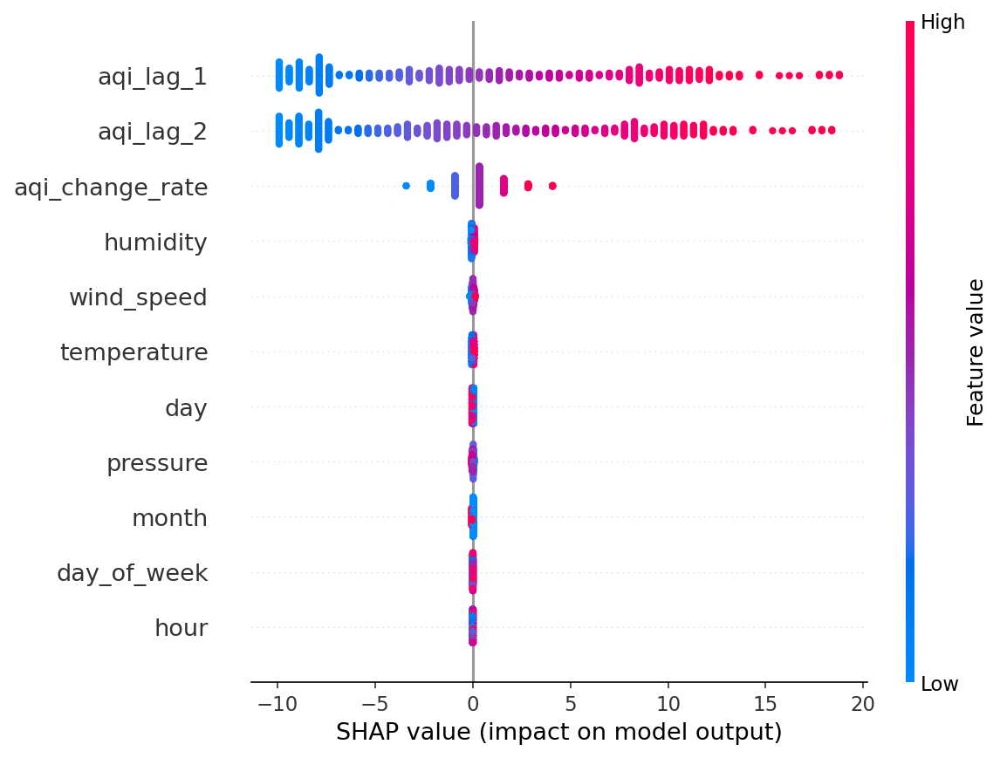
Figure 3. SHAP summary for the weather-based model — AQI lag terms matter most, but no feature is fully deterministic.

6. Forecasting Results
For inference, the model predicts AQI one hour at a time across a 72-hour horizon: each step uses the real weather forecast for that hour plus the previous hour's predicted AQI as a lag feature, feeding forward recursively. Figure 4 shows a live 3-day forecast for Sukkur.
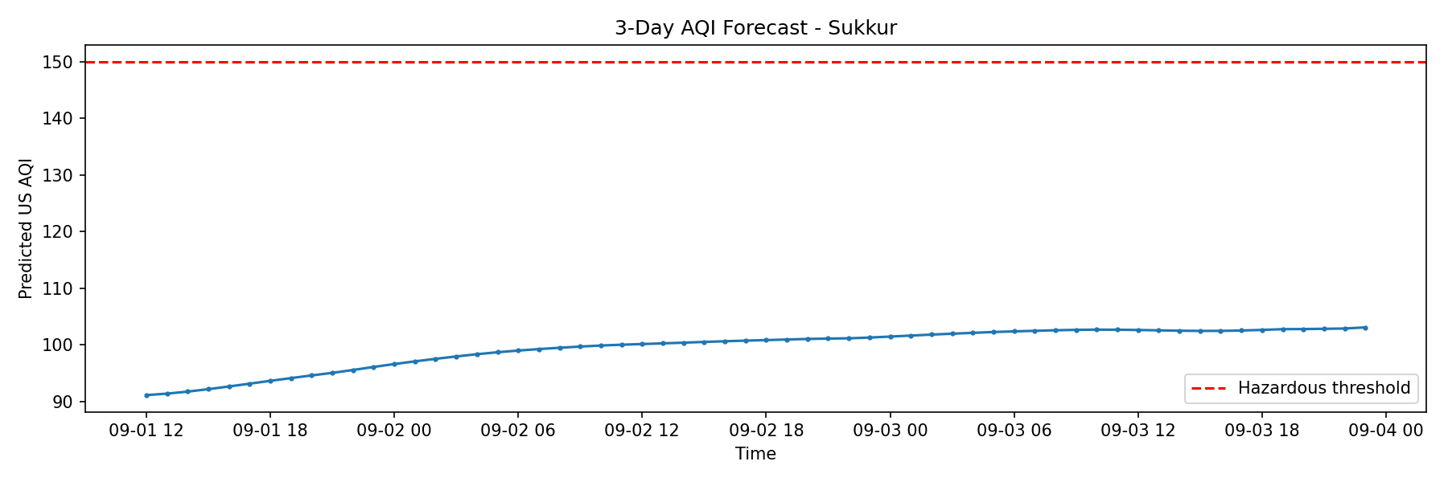
Figure 4. 3-day AQI forecast for Sukkur, with the hazardous-AQI alert threshold (150) for reference.
This forecast ranges from about 91 to 103 — comfortably within the “Moderate” category and well below the hazard threshold of 150, so no alert fires. I verified the alert logic separately by lowering the threshold during testing and confirming it triggers correctly.

7. Automation and Web Dashboard
- feature_pipeline.yml — runs every hour, keeping the feature store current.
- training_pipeline.yml — runs once daily, retraining and refreshing the deployed model.
The dashboard is built with Streamlit and deployed on Streamlit Community Cloud directly from GitHub, keeping the system serverless end-to-end. It loads the latest model, generates the 3-day forecast, displays current AQI and model performance, shows a hazard banner when needed, and plots recent historical AQI for context.
GitHub Repository: https://github.com/MudasirAliSandano/pearls-aqi-predictor

8. Technology Stack
Category | Tools / Libraries
Language | Python 3.11
Data Sources | Open-Meteo, OpenWeather Air Pollution API
Data Handling | pandas, numpy, requests
Machine Learning | scikit-learn (Ridge, Random Forest), TensorFlow/Keras (Neural Network)
Explainability | SHAP (TreeExplainer)
Feature Store / Registry | Hopsworks (local fallback for development)
Automation | GitHub Actions (hourly + daily workflows)
Dashboard | Streamlit, deployed on Streamlit Community Cloud
Version Control | Git / GitHub

9. Conclusion
This project gave me a complete, automated, serverless AQI forecasting system for Sukkur that meets every requirement in the brief: an end-to-end feature/training/inference pipeline, GitHub Actions automation, a live interactive dashboard with hazard alerting, and this report. Just as importantly, I caught and corrected three realistic data-leakage pitfalls along the way, which taught me more about rigorous time-series evaluation than a clean run would have.
Going forward, I would prioritize the weather-based feature set for genuine multi-day forecasting, since temperature, humidity, wind speed, and pressure can be forecast independently days in advance, unlike pollutant concentrations. Other next steps include completing the full Hopsworks integration, exploring sequence models such as LSTMs, extending the system to additional cities, and replacing recursive forecasting with a direct multi-step model to reduce compounding error.

Appendix A: Original Project Brief
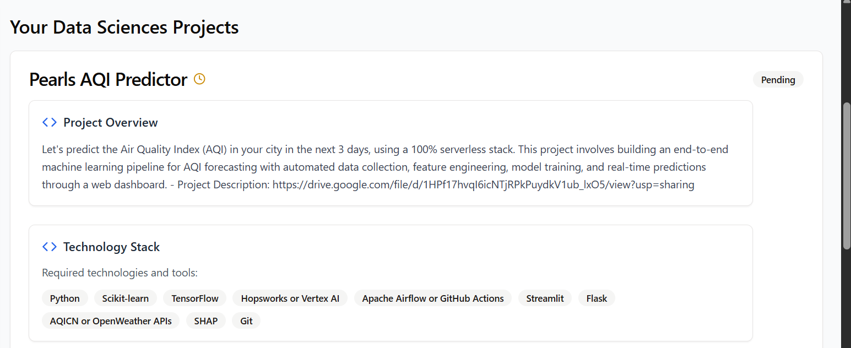
Project overview and required technology stack.
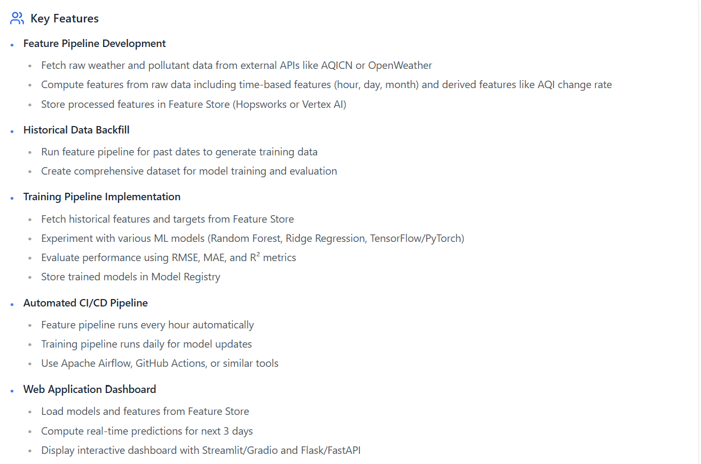
Key features required across the feature, training, automation, and dashboard components.
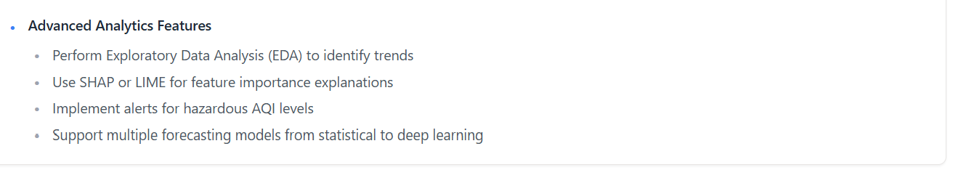
Advanced analytics requirements.

